**Réseaux/Networks**

**TP3**

G13 :

GUO Xiaofan

Zhao Chao

Piotr Bonar

# Packet Tracer - Designing and Implementing a VLSM Addressing Scheme

**Ex1/ Part1/**Step1/

5 subnets.

**Ex1/ Part1/**Step2/

**Ex1/ Part2/**Step1/

**Ex1/ Part2/**Step2/



**Ex1/ Part2/**Step3/

**Ex1/ Part2/**Step3/a

**Ex1/ Part2/**Step3/b

**Ex1/ Part2/**Step3/c

**Ex1/ Part2/**Step3/d

**Ex1/ Part3/**Step1/



**Ex1/ Part3/**Step2/



**Ex1/ Part3/**Step3/



**Ex1/ Part3/**Step4/

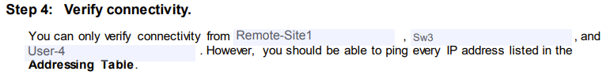

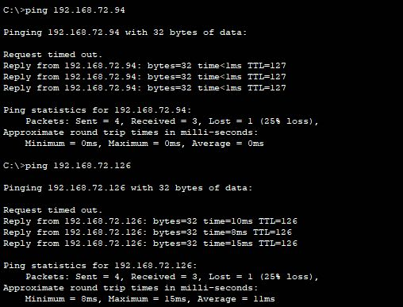

**Ex1/Activity Results**

# Skills Integration Challenge-Configuring and Testing the Lab Network

**Ex2/ Task1/** **Addressing Table**

|  |  |  |  |  |
| --- | --- | --- | --- | --- |
| Device | Interface | IP Address | Subnet Mask | Default Gateway |
| R1-ISP | Fa0/0 | 192.168.3.78 | 255.255.255.240 | N/A |
| S0/0/0 | 192.168.3.98 | 255.255.255.252 | N/A |
| R2-Central | Fa0/0 | 192.168.3.30 | 255.255.255.224 | N/A |
| S0/0/0 | 192.168.3.97 | 255.255.255.252 | N/A |
| PC 1A | NIC | 192.168.3.1 | 255.255.255.224 | 192.168.3.30 |
| PC 1B | NIC | 192.168.3.2 | 255.255.255.224 | 192.168.3.30 |
| Eagle Server | NIC | 192.168.3.77 | 255.255.255.240 | 192.168.3.3 |
| S1-Central | VLAN1 | 192.168.3.29 | 255.255.255.224 | N/A |

**Ex2/ Task1/**

**Ex2/ Task2**/R1-ISP

**Ex2/ Task2**/R2-Central

**Ex2/ Task2**/S1-Central

**Ex2/ Task2**/PC-1A

**Ex2/ Task2**/PC-1B

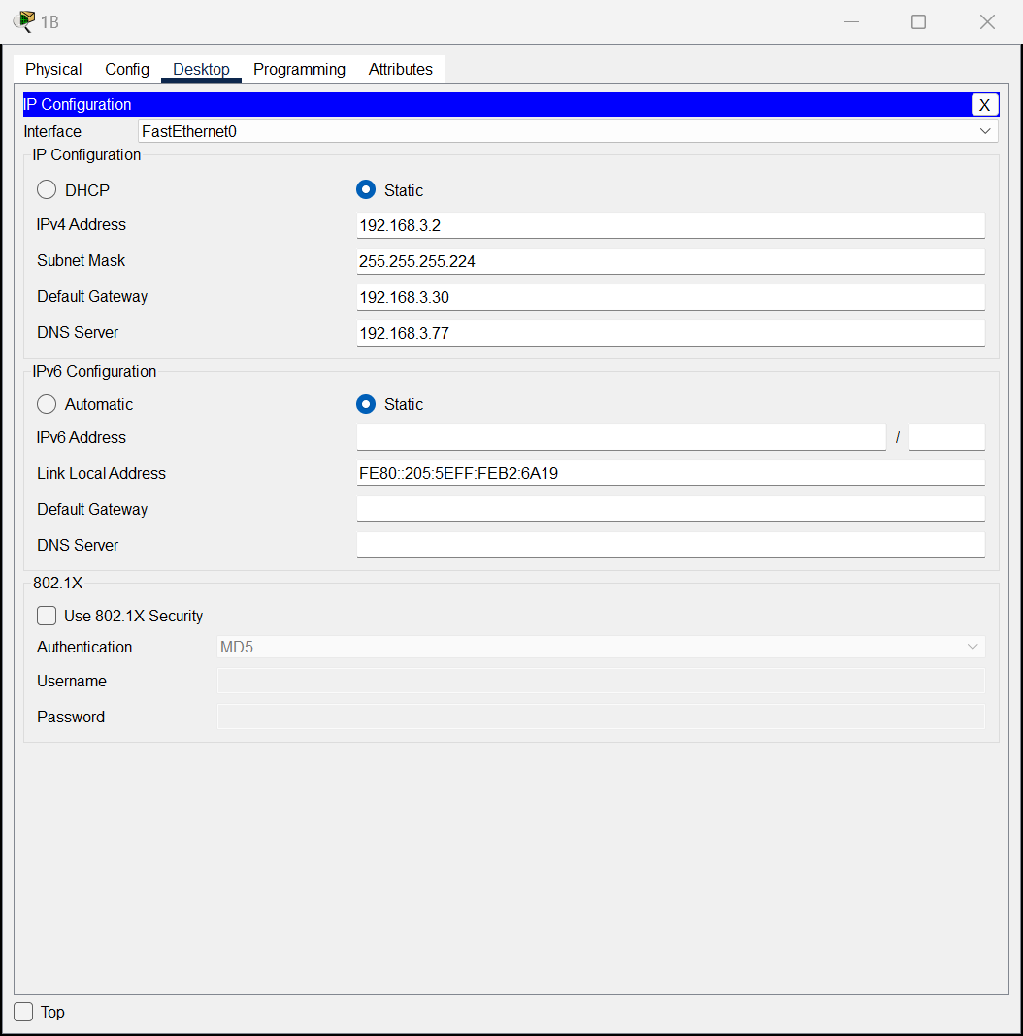

**Ex2/ Task2**/ Eagle_Server

**Ex2/ Task2**/DNS&HTTP

**Ex2/ Task3/1-Test connectivity**

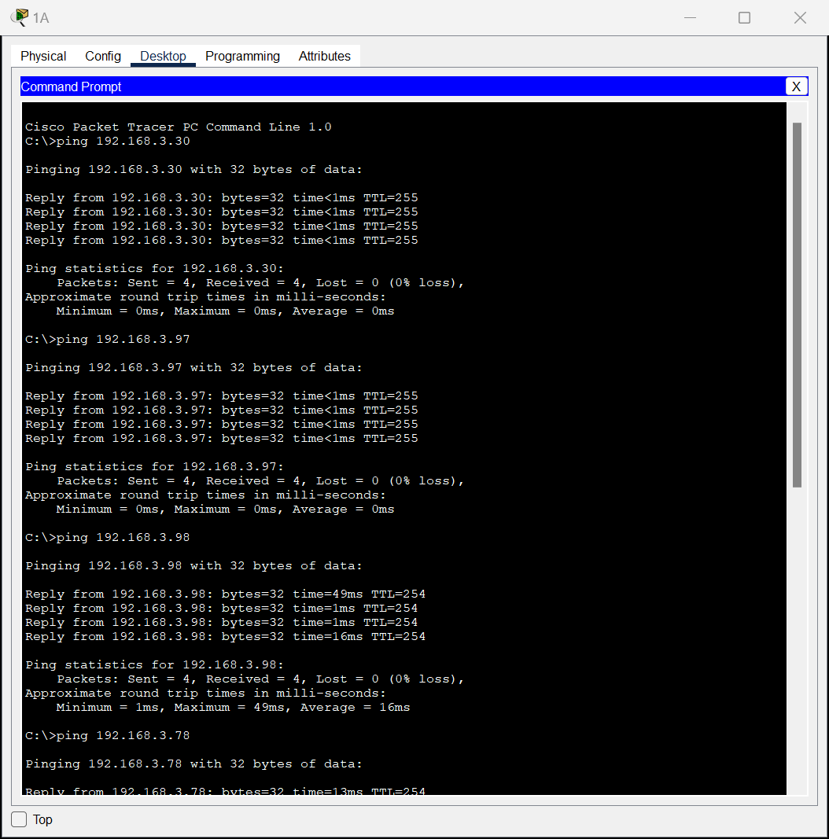

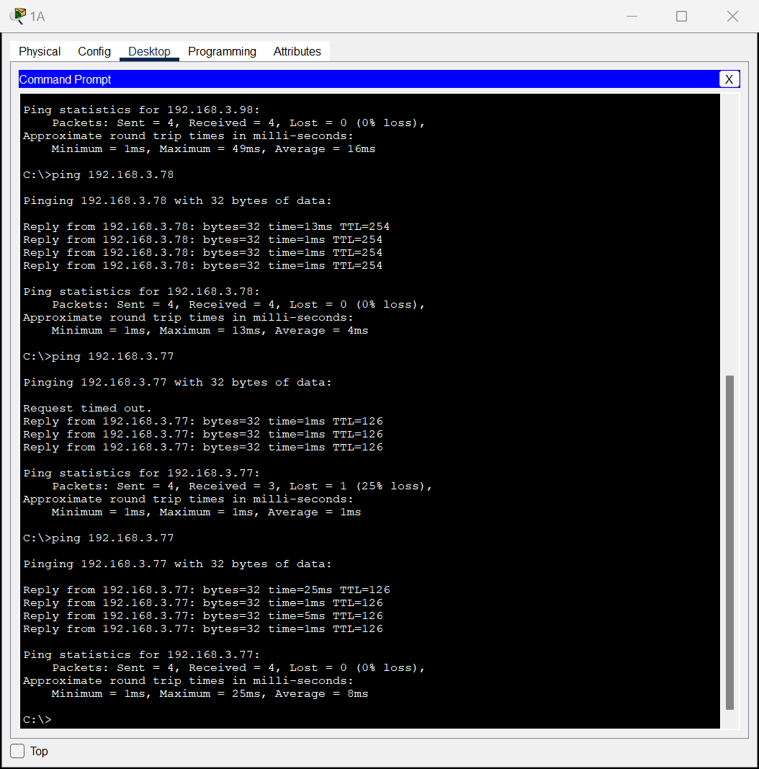

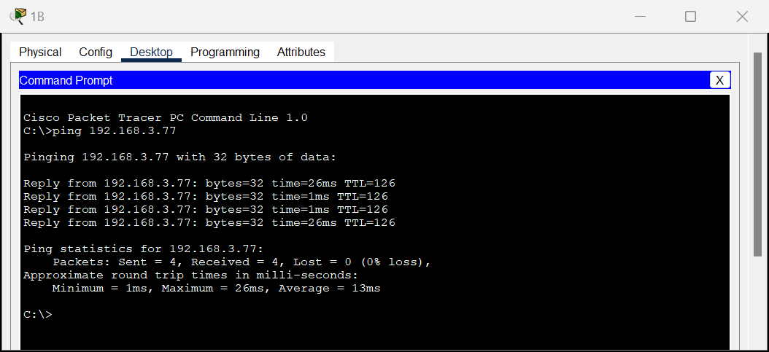

**Ex2/ Task3/** **2-Test management connections using Telnet.**

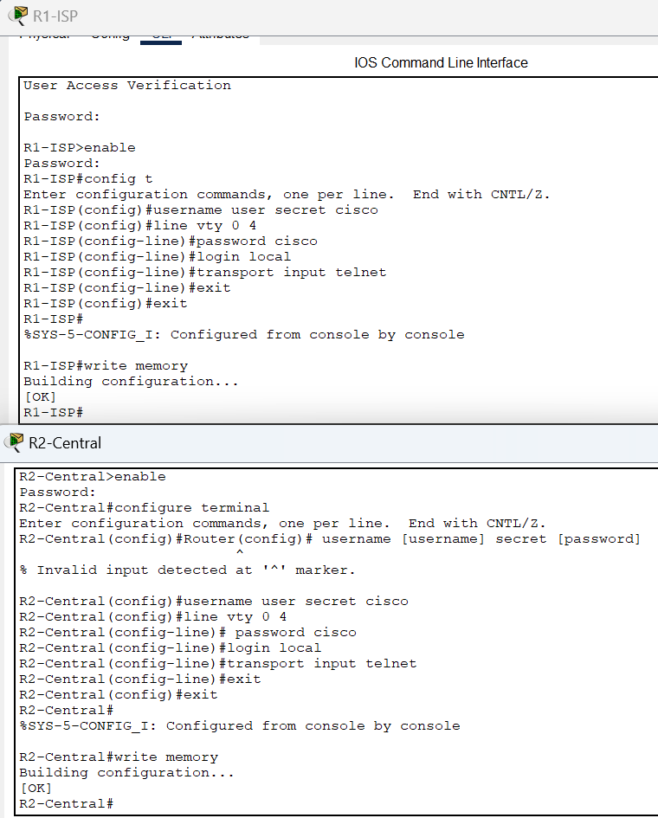

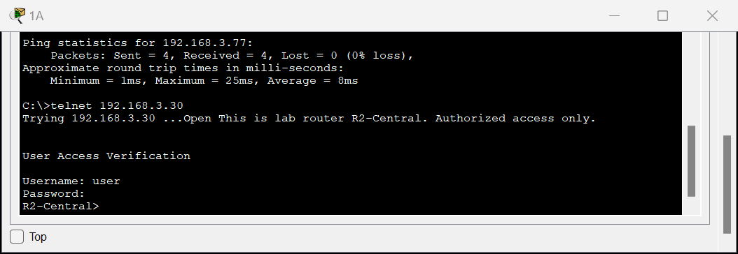

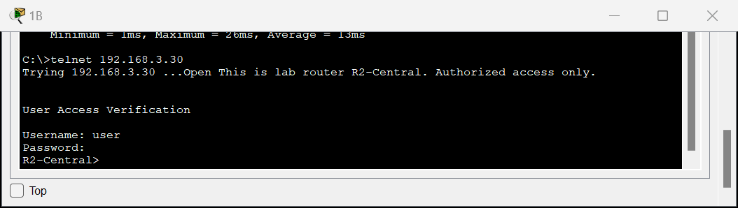

**Ex2/ Task3/** **3-Check routing table.**

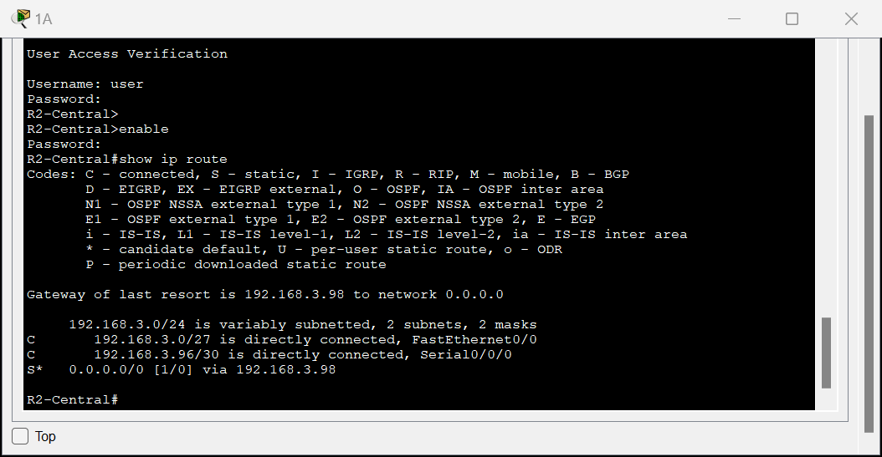

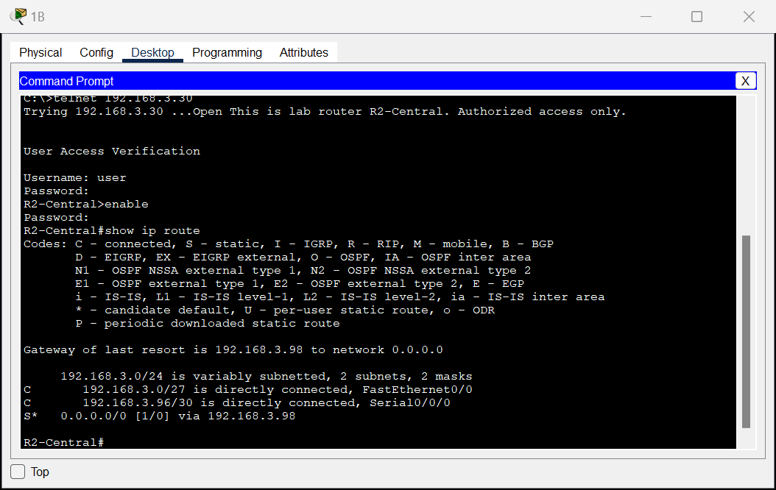

**Ex2/ Task3/** **4-** **Protocol visualization in simulation mode**

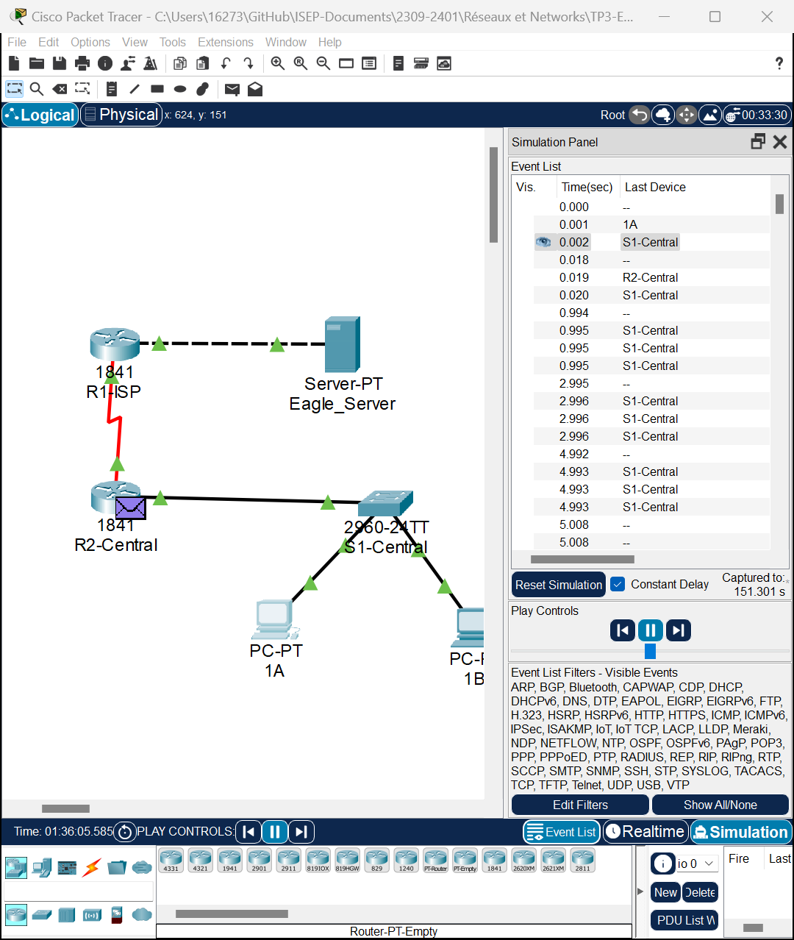

**Ex2/ Task3/** **5-** **Analyze protocol behavior**

**ARP Request Analysis:**

**Function:** The Address Resolution Protocol (ARP) is used to map network layer IP addresses to link layer MAC addresses.

* Algorithm Steps: When a device wants to communicate with another device on the same local network but doesn't know its MAC address, it generates an ARP broadcast request.
* The ARP request contains the sender's IP and MAC addresses and the target device's IP address, but the target's MAC address field is empty, as that's the information it's seeking.
* All devices on the network receive this ARP request, but only the device with the matching IP address will respond.
* The target device sends back an ARP reply containing its MAC address.
* Upon receiving the ARP reply, the requesting device stores the IP-to-MAC address mapping in its ARP cache for future use.

**ICMP Message Analysis:**

**Function:** The Internet Control Message Protocol (ICMP) is used primarily for conveying problems in network communications, such as echo requests and replies generated by the ping command.

* Algorithm Steps: When you ping from one device to another, it sends out an ICMP echo request.
* The target device, upon receiving the echo request, generates an ICMP echo reply.
* If the echo request fails to reach the target (e.g., due to TTL expiration or problems along the path), devices on the network will send ICMP error messages back to the originating device, such as destination unreachable or timeout information.
* How to Analyze in Packet Tracer:
* In simulation mode, generate ARP or ICMP traffic (e.g., by using the ping command on a PC).
* Observe the event list for ARP request and ICMP message events.
* Step through each event to watch the behavior of the packet within the network.
* Analyze the detailed information window of the packets, which will show source IP, destination IP, source MAC, destination MAC (for ARP), and the specific type of ICMP message.
* For ARP requests, note how the response is returned to the requester and how the MAC address is added to the ARP table.
* For ICMP, observe how ping requests receive responses or how error messages are generated when the destination is unreachable.

**Ex2/ Task3/** **6-** **Use the traceroute command.**

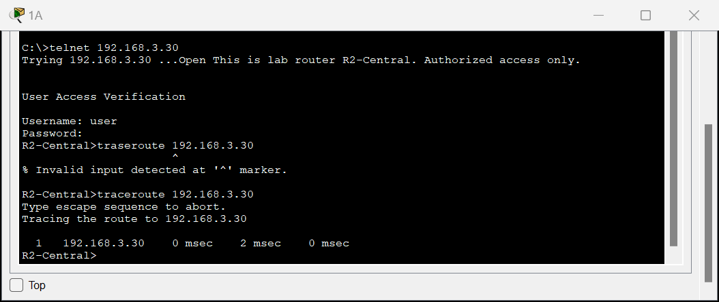

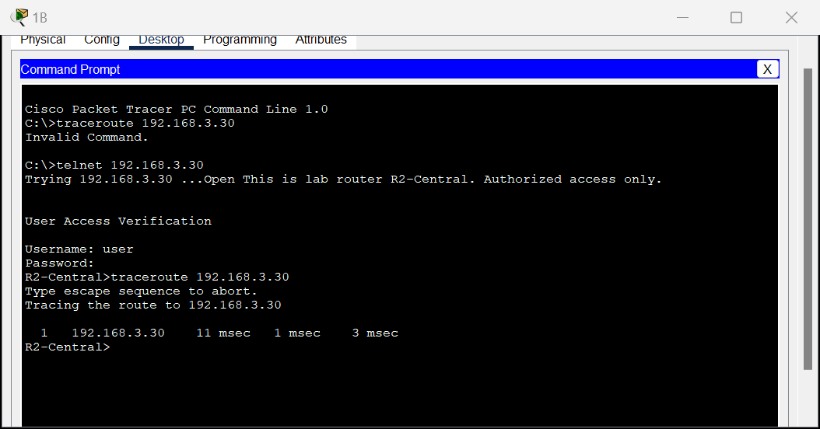

**Ex2/Activity Results**

In this network configuration and management experiment, we successfully established a basic network environment through a series of steps, and tested and managed it. The core part of the experiment involves IP address allocation, routing configuration, connection testing and remote management practice. The following are the key links and gains from the experiment:

* **Address assignment:**

IP addresses are assigned to each device based on the network design diagram, including router interfaces, switch virtual interfaces, servers, and PCs.

* **Static routing configuration:**

Since the PC cannot ping route R1 after the network connection is set up, a static route is set up on the router. This is to ensure that devices in the network can communicate with each other, especially devices that are not in the same subnet.

* **Connectivity test:**

The network connectivity was tested using the ping and Telnet commands to verify the correctness of the network configuration and whether the communication between devices was normal.

* **Remote management:**

The process of using Telnet to remotely manage network devices, which includes access to routers and configuration management.

* **Protocol behavior observations:**

In simulation mode, we also observed the behavior of protocols such as DNS, HTTP, Telnet, TCP, UDP, ICMP and ARP.

* All the errors reported in the activity results are related to the connection port and type, so it is considered to be a system file identification problem that cannot be solved by individuals.

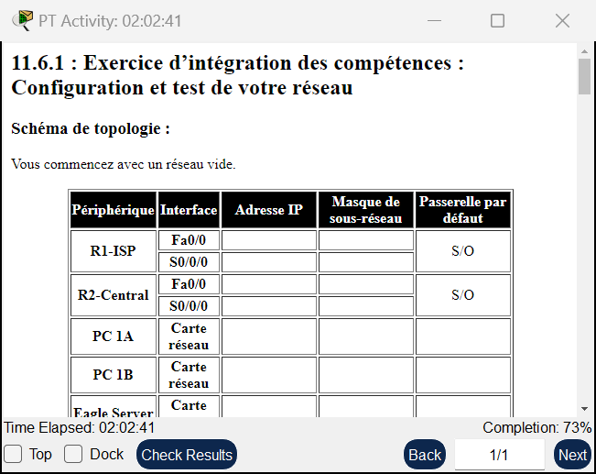

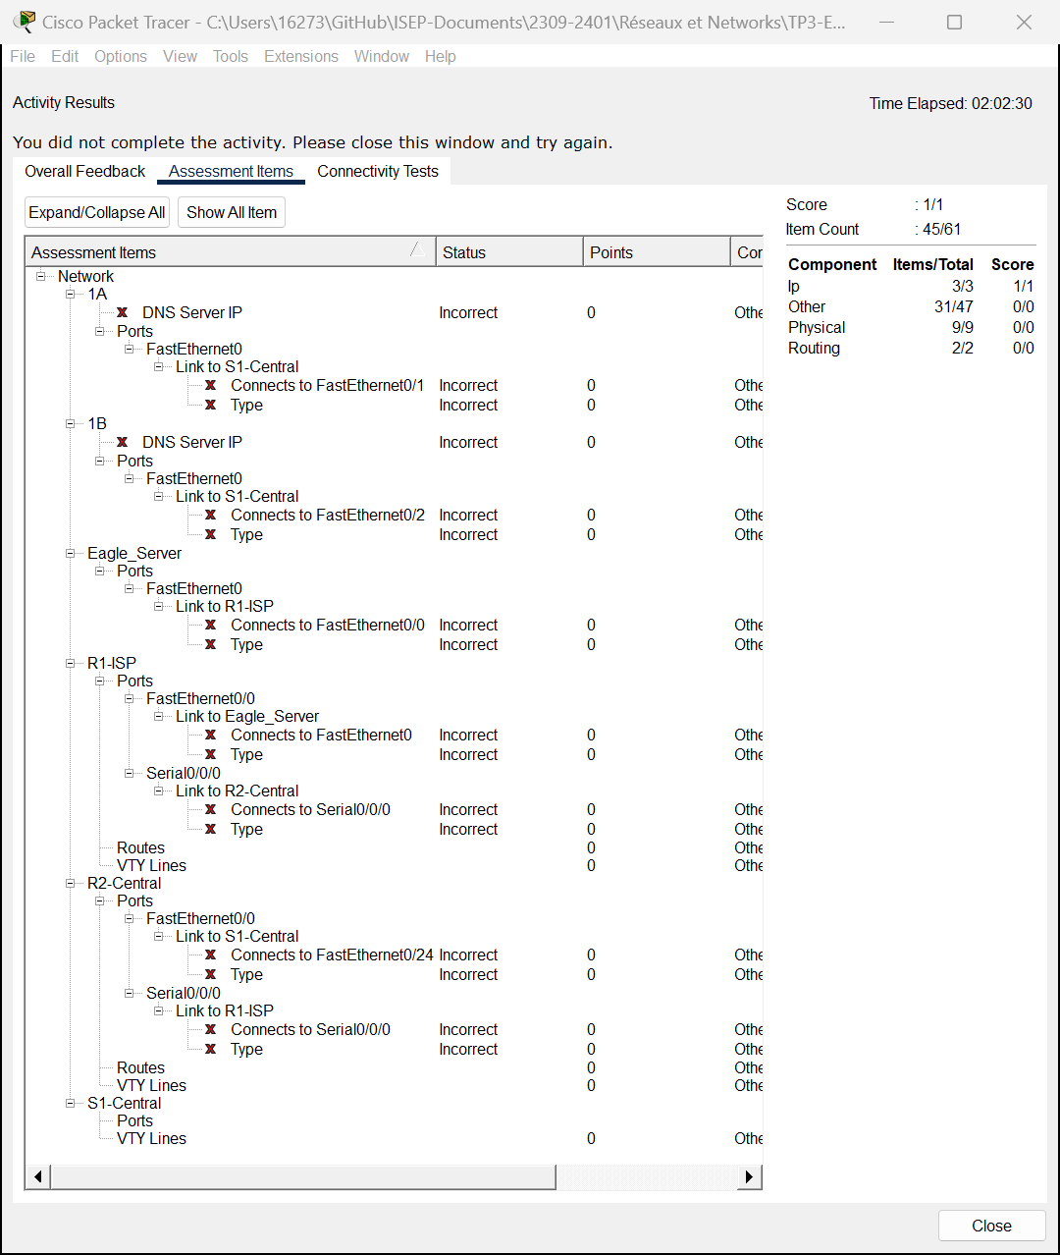

# Packet Tracer-

Implementing a Subnetted IPv6 Addressing Scheme

**

For hexadecimal, 10→a, 11→b, 12→c.

**Ex3/Part1/Step 2**/abc/Addressing Table

**Ex3/ Part2/ Step 1**

**Ex3/ Part2/ Step 2**

**Ex3/ Part2/ Step 3**

**Ex3/Activity Results**

# Packet Tracer - DHCP and DNS Servers

**Ex4/ Part 1/Step1**/ab

**Ex4/ Part 1/Step1**/cd

**Ex4/ Part 1/Step2**/abc

**Ex4/ Part 1/Step3**/abcd

**Ex4/ Part 1/Step4**/abc

**Ex4/ Part 1/Step5**/ab

**Ex4/ Part 1/Step5**/c

**Ex4/ Part 2/Step1**/abcde

**Ex4/ Part 2/Step2**/ab

**Ex4/ Part 2/Step2**/c

**Ex4/ Part 2/Step2**/d

**Ex4/Activity Results**

